
Comsats University Islamabad, Lahore Campus

Assignment <2> – SPRING 2025
Course Title | Information Security | Course Code |  | CSC432 | Credit Hours |  |  | 3(2,1)
Instructor/s | Dr. Muhammad Sharjeel | Program Name |  | BSSE
Semester | 8th | Batch | FA21 | Section | A | Date | March 18, 2025
Time Allowed | 1 week | Maximum Marks
Student Name: | Aoun-Haider | Reg No. |  | FA21-BSE-133

Question Statement [CLO-2]; Bloom Taxonomy Level: <Applying>
Research ARP spoofing and ARP poisoning. Write a paragraph explaining your understanding of how ARP spoofing relates to data interception, session hijacking, and denial-of-service attacks. Download and install Ettercap. Demonstrate a MITM attack with Ettercap using ARP spoofing. Read about Cain & Abel (software) and explain how it relates to Ettercap. Describe how a simple command ‘arp -a’ provides protection against ARP poisoning. What are the other ways to prevent ARP poisoning.
Solution:
ARP (Address Resolution Protocol) is used to map IP address to MAC address in a local network. For example, if I want to communicate with some other device, my device has to figure out its MAC address using its IP address. My device will broadcast a packet in local network containing IP address of other device, and the corresponding device to which this IP belongs will respond.
My Device: Who has IP 192.168.0.1? Tell me your MAC address
Other Device(s): **Ignore the message**
Target Device: I have IP 192.168.0.1 and MAC address is AA: BB: CC: DD: EE: FF
Intruder: **Hijacks the message** [message: I have IP 192.168.0.1 and MAC address is BD: FA: CC: DD: BB: AA]
My Device: I am sending you 3000 rupees, tell me your account no.

What is ARP Spoofing and ARP Poisoning?
Intruder pretends to have the IP address of the other device and returns his MAC address (ARP Spoofing) and now receives the traffic from my device. Intruder can also corrupt the ARP table to disable communication with other devices. So, he can send a fake reply or can get access to ARP table and corrupt it or modify a specific entry against IP address.
ARP Spoofing focus is faking identity while ARP Poisoning can alter ARP cache entries or corrupt it to disrupt/intercept communication.
ARP Spoofing = Pretending to be another device
ARP Poisoning = Corrupting the ARP cache of a victim

How ARP spoofing relates to data interception, session hijacking, and denial-of-service attacks?
The attacker spoofs the MAC address of the victim using ARP Spoofing and can now read, modify and forward the data to the actual router so the victim remains unaware. (Data Interception, Man in the middle attack MITM)
The attacker taker over a user’s active session like login session for a bank or social media account. Attacker performs ARP spoofing to intercept traffic and then steals the victim’s cookie session and finally reuses the session cookie to impersonate the victim. (Session Hijacking)
Attacker can disrupt the network communication making it unusable for victims. The attacker poises ARP tables of multiple devices causing them to send packets to the wrong destination. Victim’s device cannot communicate properly leading to network failure or slow performance. (Denial of Service Dos)
Demonstrate a MITM attack with Ettercap using ARP spoofing.
Starting Ettercap:


Starting Ettercap (Cont):
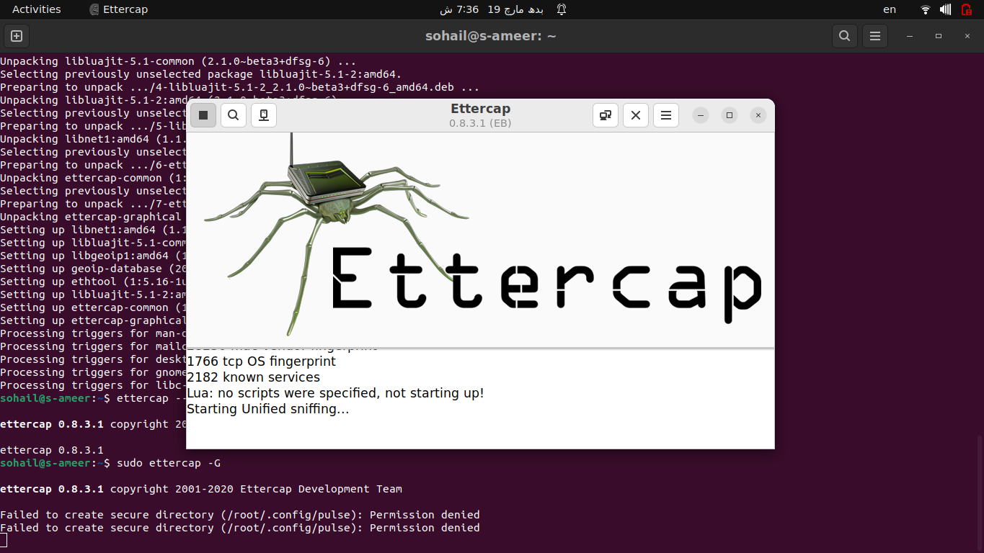
Adding target host:
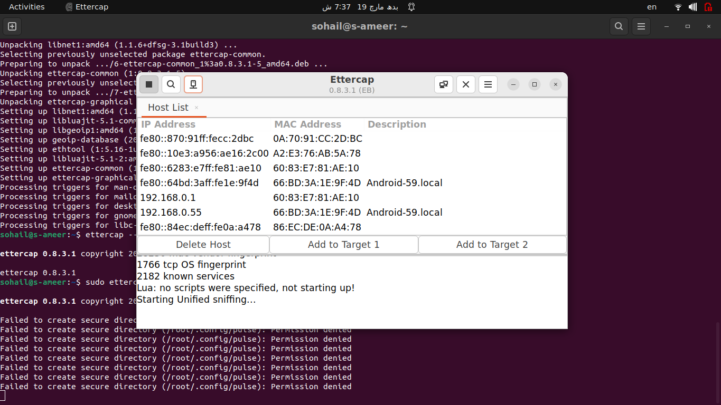

Checking connections:
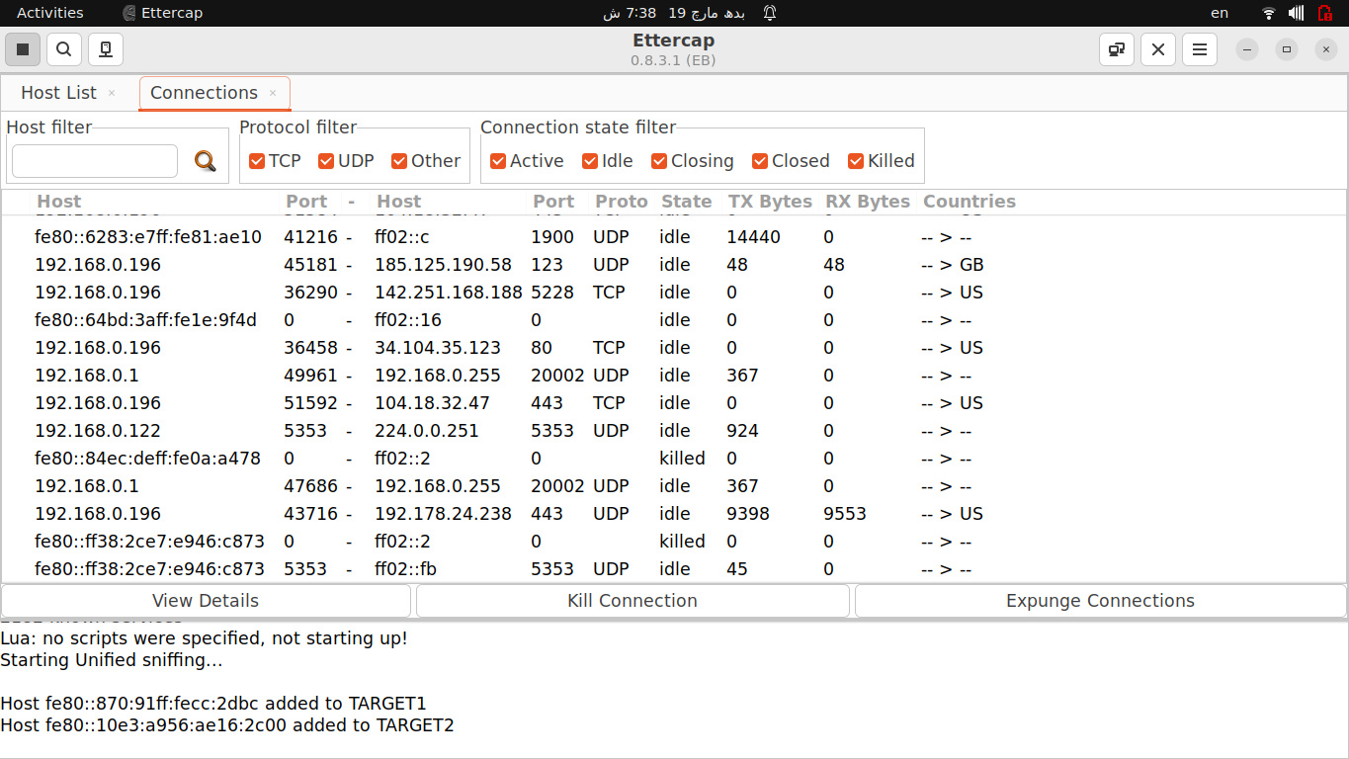
Checking Profiles:
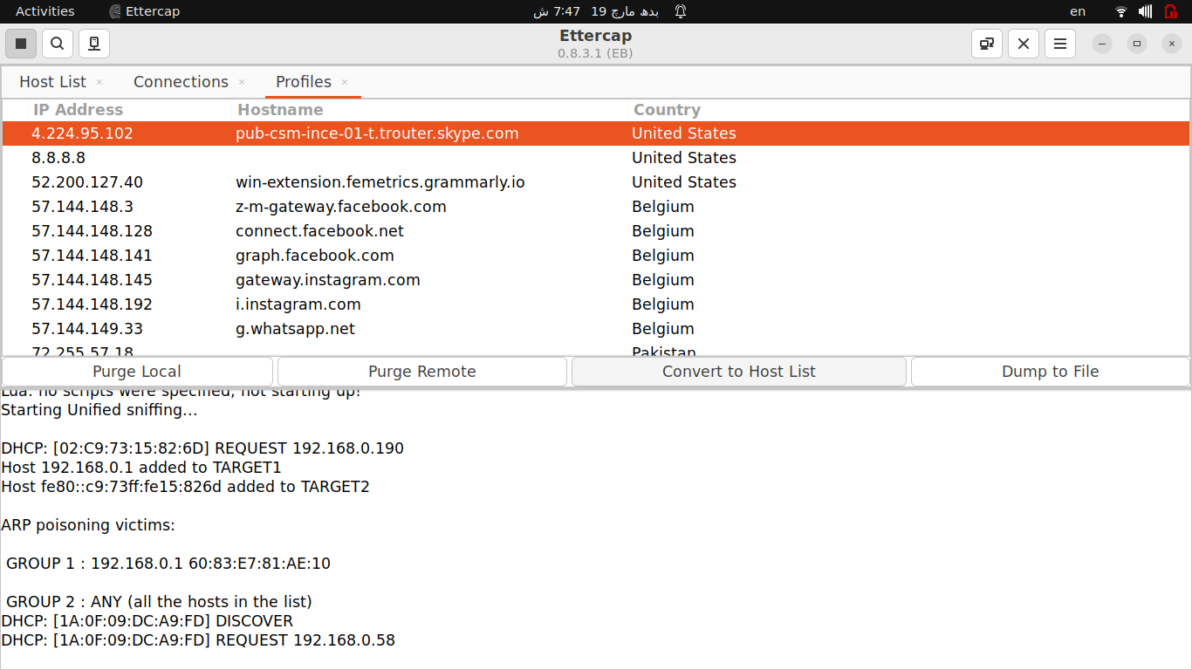
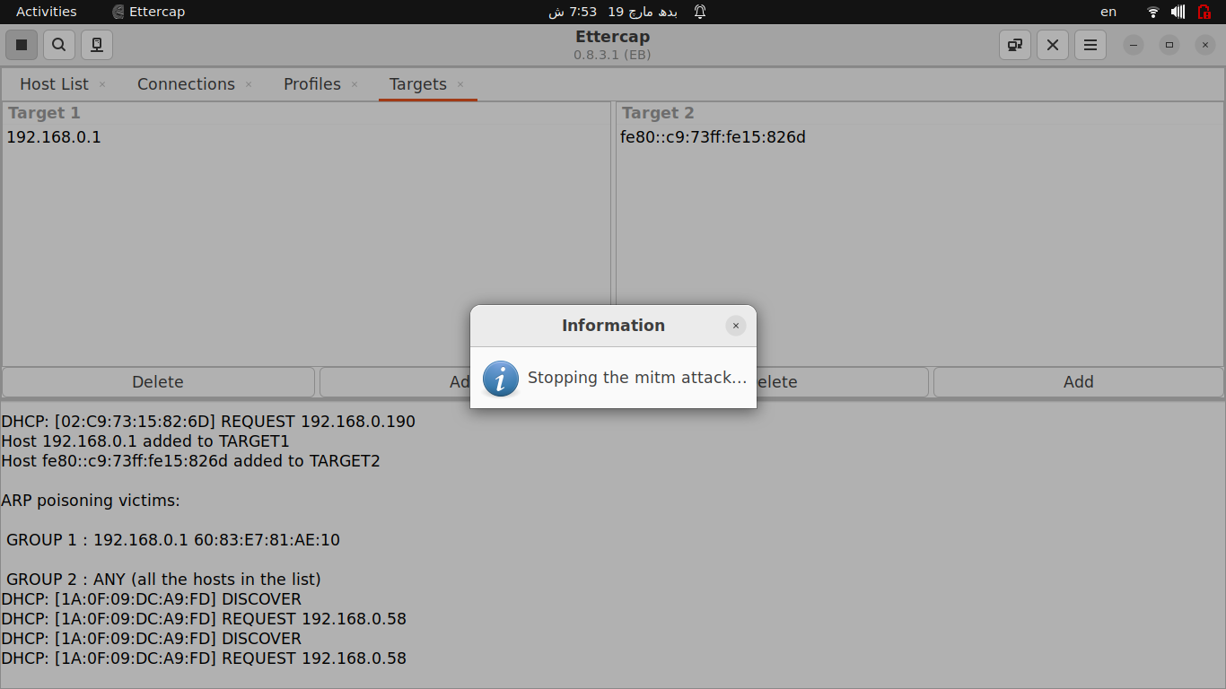

How Cain & Abel (software) relates to Ettercap.
Both can be used for Man in the Middle Attack (MITM) using ARP Spoofing but differ in features, platform compatibility and attack capabilities. For advance MITM attacks, attacker could use Ettercap while for advance traffic manipulation, Cain & Abel can be used.
Describe how a simple command ‘arp -a’ provides protection against ARP poisoning.
This command shows all IP to MAC address mapping entries of ARP table. It does not provide some mechanism to protect against ARP poisoning but can help to detect it. Normally, each IP address should have a unique MAC address but if a specific MAC address exist multiple times against different IP addresses, it could indicate ARP poisoning.
What are the other ways to prevent ARP poisoning?
- Try to manually set MAC address against IP address using “arp -s IP_Address MAC_Address”
- Use network monitoring tools like Wireshark
- If using a managed switch, enable Dynamic ARP Inspection (DAI) to filter spoofed ARP packets.
- Write a script in some programming language which can detect multiple MAC addresses in ARP table.
- Use VPN or secure protocols like HTTPS, SSH, TLS
- Use IPV6 instead of IPV4 which contains built-in mechanism for secure neighbor discovery
- Enable port security on switches

